Introduction
Body Paragraph 1
Body Paragraph 2
Body Paragraph 3
Conclusion
General
Specific
Thesis statement: controls the idea of the paper, should be the last sentence of the introduction
Specific
General
Restate thesis statement

Literary Analysis Outline

- Introduction (from general to specific)
  - Hook (startling idea, question, short quote, universal application of theme etc.)
  - Background information (mention of the author and title italicized)
  - Introduce your topic more specifically
  - Thesis statement (provable, debatable, not obvious, specific, insightful inference answering “how/why,” tells “so what”)

- Body Paragraphs (minimum of 3)
  - Topic Sentence (glue words + how/why extension phrase)
  - Lead-in
  - Evidence (direct quote or example)
  - Commentary/Analysis
  - Clincher/transition

- Conclusion (from specific to general)
  - Restate the thesis (in different words)
  - Summarize the main ideas
  - Leave the reader thinking (expand on your main ideas, give a new insight/perspective, ask a novel question etc.

Fill out the following graphic organizer to prepare your evidence (20 points). Total: ____________/20

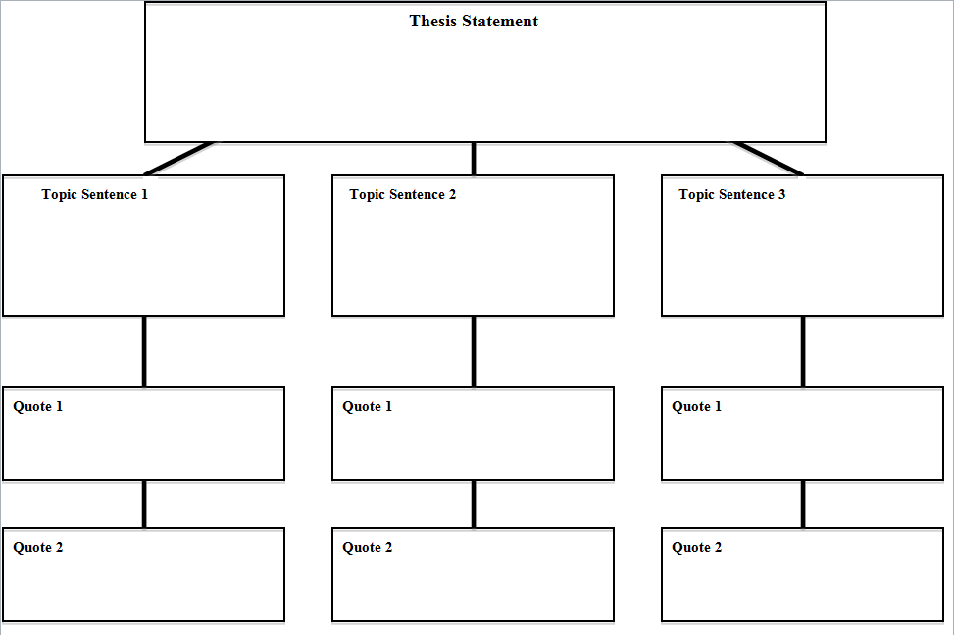

Do all of your topic sentences support your thesis statement by using glue words and a how or why extension phrase?
Does each paragraph have a clearly stated main idea? Are your quotes effectively categorized to support the main idea of the paragraph?

