IB Literature Name:________________
A Streetcar Named Desire Blogging

The A Streetcar Named Desire blog is a forum for you to interact with the text, your classmates, and myself as you read. Please review the following expectations:

- R-E-S-P-E-C-T: same as in class. Play nice.
- Be honest: same as in class. It's fine if you're not in love with everything you read or hear, but give respectful, honest, analytical explanations for your opinions. Challenge yourself to disagree with your peers and/or the author, but once again, do so respectfully and analytically.
- Post only on your class's blog on the appropriate page.
- Please type your full name and a creative title on the top line of your comment. This will help us keep track of who is responding to what.
- You may write in the first-person, informally. That being said, please write in complete sentences and keep your comments relevant and appropriate.
- All entries must be a minimum of 200 words, but please, no more than 350. Although you are not required to answer the questions below, I encourage you to use them to give you ideas.
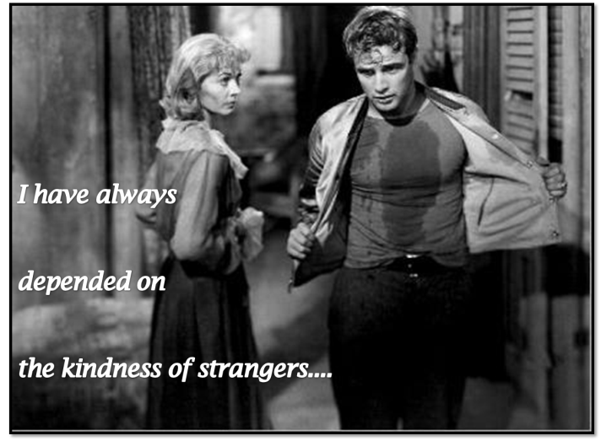
- All entries must include three components: questions (these may be to stimulate discussion, challenge a peer, or to ask something that you are genuinely curious or confused about), quotes (from the play or other sources, using MLA formatting), and connections (to anything else you've read, heard, seen, experienced, learned in history/literature or other classes etc.). You will be graded on how you respond to the text in light of these three components.
- All quotes must be cited using MLA formatting.

As you read A Streetcar Named Desire, post FIVE blog entries:

1.) Blog entry #1: Intro and scenes 1-2
2.) Blog entry #2: Scenes 3-4
3.) Blog entry #3: Scenes 5-6
4.) Blog entry #4: Scenes 7-8
5.) Blog entry #5: Scenes 9-11

These may be general reactions to the text, a response to any of the reader response questions listed below, a response to another student’s blog post, a reaction to a significant quote, incident, or character etc. but all posts MUST be at least 200 words and include questions, quotes, and connections as explained in #7 above. Each blog post is worth 10 points. Late blogs will result in a deduction of 2 points per day.

Optional Reader Response Questions (to get you thinking…) (from You Gotta Be the Book by Jeffrey Wilhelm)
- What do you think the author wanted to set up or foreshadow in the first few sentences, paragraphs, or pages?
- What do you know that helped you understand the reading? What might you need to know more about to help you understand?
- How does the author develop the characters’ personalities?
- Did you like the characters? How are the characters like anyone you know or even like you?
- What are the characters’ problems?
- What information did the author leave out? What's happening behind the words or scenes?
- What other works have you read that are similar in some way to this one? What sticks out as the most important connection between the two?
- What did you like most/least about this book?
- Was there anything you didn't understand? What was it?
- What idea was the author trying to explore in this work? How important is that idea?
- If you were to make a movie of this story, who would be in the movie? What would you change to make the movie fit two hours? What kind of setting would you choose?
- What literary devices and techniques are being used? What is the purpose of such devices?
- Do you agree with how the author or characters see the world? In what ways?
- What do you feel is the most significant passage/word/event from the novel?
IOP and SCND Timeline 2013
Due Date | Assignment | Point Value
Friday, November 8th | Read the introduction and scenes 1-2. Post on the blog. | 10 (homework grade)
Tuesday, November 12th | Completed IOP proposal form, downloadable via edmodo, must be typed and printed to be considered on time. | 25 (mini-project grade)
Thursday, November 14th | Read scenes 3-4. Post on the blog. | 10 (homework grade)
Monday, November 18th | Read scenes 5-6. Post on the blog. | 10 (homework grade)
Wednesday, November 20th | IOP presentation outline due | 15 (quiz grade)
Friday, November 22nd | Revised presentation outline using track changes  (Yes, you are in SALMUN this day, but you are also an IB student and this is an HL class. Please turn in you revised outline using track changes on edmodo by 8pm on this day! | 15 (homework grade)
Tuesday, November 26th | Read scenes 7-8. Post on the blog. | 10 (homework grade)
Monday, December 2nd | Read scenes 9-11. Post on the blog. | 10 (homework grade)
Wednesday, December 4th | Film practice project. See assignment for details. | 100 (project grade)
Week of December 3rd -7th | IOP final performance | 30 marks: 15% of your final mark in IB literature. 50% of your semester exam grade in this class. Internally assessed using mark scheme, externally moderated.
Tuesday, December 10th | Midterm Exam on unseen Paper 1 passage | 50% of your semester exam grade in this class. Assessed using Paper 1 rubric.

***Ms. B. reserves the right to readjust dates and assignments! All late work will result in a 2 point deduction per day. If you are going to be absent, please arrange with Ms. B. in advance. Check edmodo regularly for downloads and updates.
