IB Literature Name:_________________________
Nineteen Eighty-Four Reading Blog

While reading the novel, your assigned journal entries will be blog entries. There are many possible options for a blog, but they will all be graded based on questions, specific textual citations, insight, and connections to other subject material. While ensuring that your blog entry contains the above requirements, you can choose from any of the following options. Be sure, however, that you respond to a variety of options over the course of the whole novel; don’t choose the same ones each time. The purpose of the blog is to help you process what you read, so that you understand it and retain it better, and to spark discussion in class. This is your chance to interact with the text and each other one on one—as long as you meet the requirements of the rubric, do it your way!

Blog Entry Requirements: All entries must include questions, quotes, and connections, and they must also include at least ONE or more of the following options. Each entry should be 300 words minimum, but may be more. Each of these will be worth 10 points. You will write log entries for every other night of reading, so pay attention to assignments in class. Be sure to POST each entry under the appropriate section, as well as label which prompt you are responding to.

- Comment on the significance of a certain plot point, or passage. What would the novel be like without it? How might a certain change in this scene affect the rest of the novel?
- Quote lines from the section you enjoyed (not too long a section please) and reflect on why they appealed to you.

- Describe your reaction to a character, action, or idea you confronted in the section.

- Write a diary entry from the point of view of one of the characters. Write first person, telling events from the character’s perspective. Capture the voice of the character by using particular tone, diction, dialogue etc. Give insight into what and how he/she thinks. He/she can react to other characters or events, ponder his or her existence, or share his or her suspicions and secrets. The diary entry should accurately reflect the personality of the character who is writing it. Carefully consider how the character would feel about the events that occurred.

- Pretend you are a director or actor in a film adaptation of Nineteen Eighty-Four. How would you stage a particular scene, or act a particular role, and why? Please be thoughtful in your response.
Date | Reading and Assignments
2/3 | Part 1, Chapters 1-4
2/5 | Part 1, Chapters 5-8 + Blog post
2/7 | Part 2, Chapters 1-5
2/11 | Part 2, Chapters 6-10 + Blog post
2/13 | Part 3, Chapters 1-4
2/17 | Part 3, Chapters 5-6 + Blog post
2/19 | Appendix: The Principles of Newspeak  Part 3 + Newspeak quiz
2/21 | MWDS due  Silent dialogue graffiti
2/25 | Paper 2 comparative study guide w/ BNW

- Reflect on how Winston or another character might answer the essential question, “How does language control thought/behavior?” “How do we know who we are?”

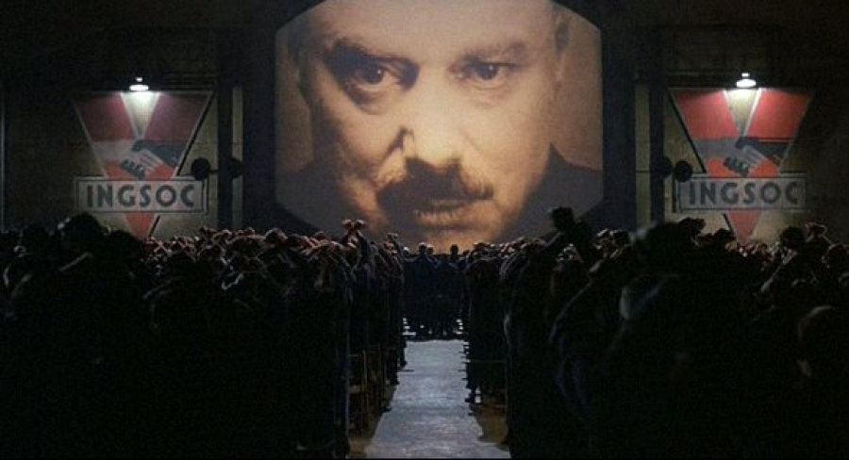
BIG BROTHER IS WATCHING YOU.
BIG BROTHER IS WATCHING YOU.
BIG BROTHER IS WATCHING YOU.
BIG BROTHER IS WATCHING YOU.
BIG BROTHER IS WATCHING YOU.

