English 12 Name:____________________
June/July Reading Assignment

“I been silent so long now it’s gonna roar out of me like floodwaters and you think the guy telling this is ranting and raving my God; you think this is too horrible to have really happened, this is too awful to be the truth! But, please. It’s still hard for me to have a clear mind thinking on it.
But it’s the truth even if it didn’t happen” (Kesey 13).

that being said…

WELCOME TO GRADE 12 ENGLISH!

Over the course of the year, we will encounter several characters whose sanity will cause us to question their reliability, and whose shifting notion of truth may challenge our own. One Flew over the Cuckoo’s Nest is only the beginning! I’m giving you a fast read for the summer, one that should make you laugh as it simultaneously horrifies the hell out of you. Did I just say hell in an assignment? Sorry, that’s Chief Bromden rubbing off on me. You’ll see what I mean soon enough…

Now, no one exactly jumps for joy at the idea of summer reading, but if you complete the enclosed assignment, I can assure you will have a thought-provoking reading experience followed by a smooth transition into Grade 12 English.

One Flew over the Cuckoo’s Nest is Ken Kesey’s fever dream of a manifesto on the sounds of silence, sanity, and identity. It is a work that is far more complex than its fast-paced prose might suggest, so pay careful attention to what kind of commentary Kesey might be making on the relationship between society and the individual.

As you read the novel, track and identify evidence to assist you in answering the seven questions as outlined on the following page in typed, double spaced paragraphs. Each question is worth 10 points, for a total of 70. Your answers will be graded for clarity, completeness, depth, evidence, and analysis.

Instructions can be found both in this packet and at www.pasbenglishmsb.weebly.com, where you can download this entire packet on the One Flew over the Cuckoo´s Nest page and email me with any questions, concerns, or doubts you might have. My email address is alexandra.brostoff@gmail.com, and I tend to answer email inquiries extremely fast!

Looking forward to a new year with you all
Ken Kesey’s One Flew over the Cuckoo’s Nest Questions (70 points)
Write a short paragraph (at least 4 sentences) responding to each of the following questions in thoughtful, complete sentences. Use quotes as evidence to support your claims. Be sure your answers are typed, double-spaced, and proofread. Each question is worth 10 points, for a total of 70. This assignment will be due by the end of the first week of school with 5 points extra credit if turned in on the first day of class. Late work will result in a deduction of 5 points per day.
- State whether you believe Chief Bromden is a reliable narrator or not. Why do you think Kesey chose to tell this story from the Chief’s point of view? Cite incidents from the novel to support your answer.

- In what ways do the men change on the fishing trip? What change does Chief Bromden observe in McMurphy on the way back to the hospital?

- Cite at least three quotes to explain the symbolic significance of each of the following motifs in Chief Bromden´s hallucinations:
- Machines and The Combine
- Fog
- Time control

- What is the importance of laughter in this novel?

- Many critics believe Kesey intends McMurphy to be a heroic, Christ-like martyr. Do you agree or disagree with this theory? Cite incidents from the story to support your answer.

- Comment on the ending to this story. How does the ending reflect on a man’s right to be an individual versus society’s need for conformity?

- Discuss the significance of the title and what birds may symbolize in this story.
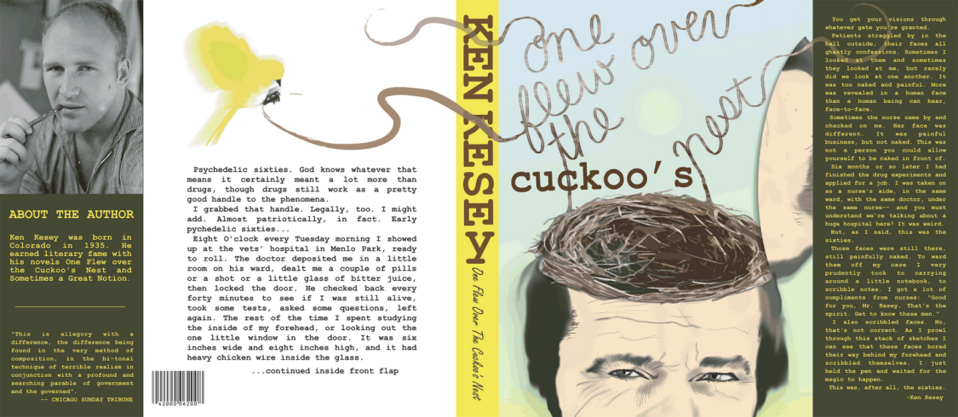

See http://pasbenglishmsb.weebly.com/extra-credit.html
for an optional extra credit assignment!

