English 12 Name:____________________
January/February Reading Assignment

What if human life were manufactured? What if sadness were extinct? What if one little pill was the benefactor of interminable buoyancy? “O wonder!” Miranda exclaims, in Shakespeare’s The Tempest, “O brave new world” (5.1.203-206).
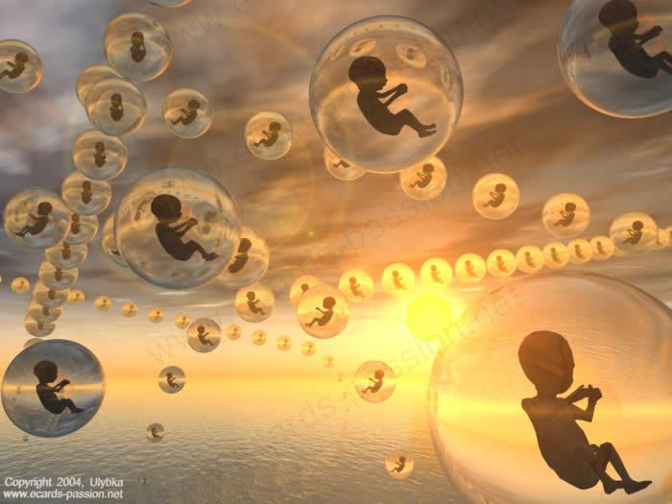
It is ironically thus that Aldous Huxley’s Brave New World dreams up a species of happiness designed to immunize a genetically regulated race into submissive oblivion. In a world where resources never run out, education is automatic, sex is recreational, and everyone is happy, what could possibly go wrong? Welcome to Brave New World, where you will shudder to imagine how our widening world of technological innovation might just be humanity’s one-way ticket towards ruthless despotism and merciless dystopia.
Now, no one exactly jumps for joy at the idea of summer reading, but if you complete the enclosed assignment, I can assure you will have a thought-provoking reading experience followed by a smooth transition into second semester.

Your summer reading project has two parts as outlined below:

Part I: Aldous Huxley’s  Brave New World  Reading Responses (40 points) | Part II: Aldous Huxley’s  Brave New World Questions  (70 points)
After you finish reading each set of chapters (as outlined on the template), write a reader response/reaction to that section using the template on the last 2 pages of this packet. These responses should be handwritten and limited to the space provided. Please do not write a plot summary. Naturally, you will include some plot, but I want to read your reactions to what is happening in the novel and to the characters and their personalities and motivations. Use the reader response questions to guide your responses (10 points per response for a total of 40).  Due the day of the FIRST CLASS MEETING in February. | Answer any seven of the questions as outlined on the next page in typed, double spaced paragraphs (10 points each for a total of 70 points).  Due on the SECOND CLASS MEETING in February with 5 points extra credit if turned in on the first day of class. Late work will result in a deduction of 5 points per day.

Instructions can be found both in this packet, on Edmodo, and at www.pasbenglishmsb.weebly.com, where you can download this entire packet on the English 12: Brave New World page, post your blog entries, interact with your classmates, and email me with any questions, concerns, or doubts you might have. My email address is alexandra.brostoff@gmail.com, and I tend to answer email inquiries extremely fast!

Aldous Huxley’s Brave New World Questions (70 points)

Write a short paragraph (at least 4 sentences) responding to any SEVEN of the following questions in thoughtful, complete sentences. Use quotes as evidence to support your claims. Be sure your answers are typed, double-spaced, and proofread. Each question is worth 10 points, for a total of 70. This assignment will be due on the SECOND CLASS MEETING with 5 points extra credit if turned in on the first day of class. Late work will result in a deduction of 5 points per day.
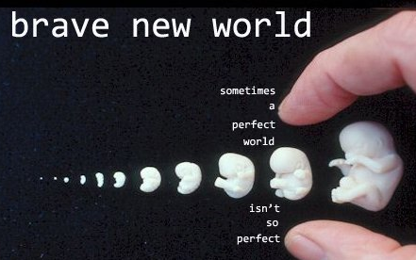
- Few of Huxley's predictions have proven to be perfectly accurate, yet many aspects of the Dystopia of Brave New World feel uncomfortably like our world. Talk about the book as a prophetic vision of the future. Which aspects of the book are most disturbing? Which hit closest to home? Which seem the most far-fetched?

- When Brave New World was first published in 1932, the world was plunged in depression, fascism was on the rise in Western Europe, and Marxism appealed to increasing numbers of intellectuals in Europe and America. Place the book in the context of its historical moment. Which parts transcend its time and place?

- Toward the end of the book, the Controller Mustapha Mond sums up the benefits of living in the "brave new world.” He explains, "The world's stable now. People are happy; they get what they want, and they never want what they can't get." It sounds like perfection, and yet the world Mond describes is deeply, intentionally horrifying. Why? What exactly is so bad about this society of the future? Is there anything good about it, anything we could learn from and try to adapt to our own uses?

- As dehumanizing and oppressive as the brave new world is, the alternative in the "savage reserve" is in many ways worse - dirty, violent, unhealthy, cruel, and uncomfortable. What point is Huxley making about human nature and the nature of human communities? Is his vision totally negative, or does the book maintain shred of hope, some alternative mode that fosters both freedom and community?

- One of the most striking - and comic - aspects of Huxley's dystopia is the way our sexual cravings and assumptions have been turned on their head: monogamy is bad, passion is deviation, casual, meaningless sex is the socially approved norm. What is Huxley insinuating here? Is there any expression of human sexuality that he finds acceptable? Is sex at the heart of the "problem" in his view of human nature?

- Talk about the morality of the book. Is it a Christian morality? Socialist? Anarchist?

- In many ways, the main characters of the book are cartoon figures - Helmholtz Watson the alienated superman, Bernard Marx the cowardly, hypocritical intellectual, Mustapha Mond the cynical all-knowing leader, John the doomed idealistic. Discuss the book as an allegory and elaborate on what each character stands for.

- When John first starts reading Shakespeare, he discovers that the words make his emotions "more real" - they even make other people more real. Talk about the power of language in the book, the power of the word to influence thought and behavior. Why did Huxley choose Shakespeare as the medium of John's intellectual awakening?

- Could anything like Brave New World really happen? Has it happened in some form that we don't fully recognize?

- Discuss the last paragraph´s tone, diction, and how it reflects on a theme in the novel?
Reader Response Sheet Name ____________________________________

Chapters 1-3 | Chapter 4-9

Reader Response Sheet Page 2
Chapters 10-15 | Chapters 16-18

