Grade 11 English Name:____________________
January/February Reading Assignment


“It’s hard to tell somebody what you mean to say. And that’s an idea that I’m obsessed with. It’s why I write.”

--Jonathan Safran Foer [April 2005]


Inside a small vase was a small envelope inside of which there was a small key. Inside a world that is Extremely Loud and Incredibly Close, inside 9-year-old Oskar Schell’s outlandish imaginings, teapots perform Shakespeare and tiny, swallowed speakers produce the sounds of the human heart on New York City streets. Here, Oscar embarks on a expedition interrupted by birds, answering machines, and the color purple written in green ink. Extremely Loud and Incredibly Close is a simple solution to an impossible problem that is at once traumatic, beautiful, and true.

Now, I know no one exactly jumps for joy at the idea of summer reading, but if you complete the enclosed assignment, I can assure you will have a thought-provoking reading experience followed by a smooth transition into next semester. That, and if you give him a chance, I suspect Oskar Schell´s unique voice will echo in your thoughts for some time to come.

Instructions can be found both in this handout, on Edmodo, and at www.pasbenglishmsb.weebly.com, where you can download this handout on the Grade 11: Extremely Loud and Incredibly Close page and email me with any questions, concerns, or doubts you might have. My email address is alexandra.brostoff@gmail.com.

Part I: Reader Responses (40 points) | Part II: Critical Analysis Questions (70 points)
- Read the attached assignment in its entirety.  - Read the book!  - As you read, neatly write or type up four informal reader responses into the template as described and outlined on the following pages (10 points per entry for a total of 40 points).  - This assignment will be due the second class of third quarter with 5 points extra credit if it is turned in on the first day of class. Late work will result in a deduction of 5 points per day. | As you read the novel, track and identify evidence to assist you in answering the questions as outlined on the last page of this packet. Answer the any SEVEN out of the ten questions in formally typed, double spaced paragraphs (10 points each for a total of 70 points). Use quotes as evidence to support your claims. Be sure your answers are MLA formatted, double-spaced, and proofread. Your answers will be graded for clarity, completeness, depth, evidence, and analysis. This assignment will be due the second class of third quarter with 5 points extra credit if it is turned in on the first day of class. Late work will result in a deduction of 5 points per day.

Part I: Reader Responses

- Read the attached assignment in its entirety.
- Read the book!
- As you read, neatly write or type up four informal reader responses into the template as outlined on the following pages (10 points per entry for a total of 40 points).

As you read, informally reflect on your reactions and reflections on the text. Respond to characters, plot, themes, etc. and how they make you feel as a reader. You do not need to answer all of the following questions, but may use them as inspiration to help you formulate your four responses. Do NOT write plot summary; you will not receive credit for it.
- What are you thinking about as you read the first paragraphs?
- What do you think the author wants you to know?
- What are you imagining might happen next?
- What do you know that is helping you understand what you are reading? What might you need to know more about to help you understand?
- What clues do you have to the character's/speaker's personality?
- Do you like the character?
- What are the character's problems?
- How is the character like anyone you know or even like you?
- What information did the author leave out? What's happening behind the words or scenes? How did you fill them in?
- What other works have you read that are similar in some way to this one? What sticks out as the most important connection between the two?
- Will you tell your friends about this work? What do you want them to know?
- What did you like most/least about this poem/story/novel?
- Was there anything you didn't understand? What was it?
- What idea was the author trying to explore in this work? How important is that idea?
- If you were to make a movie of this story, who would be in the movie? What would you change to make the movie fit two hours? What kind of setting would you choose?
- Who was telling the story? Does it make a difference? What if someone else were telling it?
- How do you recognize when literary elements are being used? (symbol, metaphor, foreshadowing, etc.)
- Do you agree with how the author sees the world? In what ways?
- How do you feel about the way the story was told? Is there anything you enjoyed or were irritated with about the way the book is written?
- What do you feel is the most significant passage/word/event from the poem/story/novel?
This assignment will be due the second class of third quarter with 5 points extra credit if it is turned in on the first day of class. Late work will result in a deduction of 5 points per day.
Reading Responses Name ____________________________________

Part I: pages 1-74 | Part II: pages 75-141

Reading Responses Page 2
Part III: pages 142-216 | Part IV: pages 216- the end
Part II: Critical Analysis Questions

As you read the novel, track and identify evidence to assist you in answering the questions as outlined on the last page of this packet. Answer any SEVEN of the ten questions in formally typed, double spaced paragraphs (10 points each for a total of 70 points). Use quotes as evidence to support your claims. Be sure your answers are MLA formatted, double-spaced, and proofread. Your answers will be graded for clarity, completeness, depth, evidence, and analysis. This assignment will be due the second class of third quarter with 5 points extra credit if it is turned in on the first day of class. Late work will result in a deduction of 5 points per day.
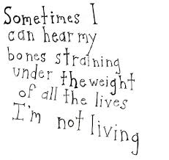
- What is the significance of the title?

- Is Oskar sympathetic or annoying? To what extent is he a believable character? To what extent does he change over the course of the plot?

- Jonathan Safran Foer has said that he writes about characters and their miscommunications: some characters think they’re saying a lot but say nothing; others say nothing but end up saying a lot. Which characters fall into which category in Extremely Loud and Incredibly Close? What might Foer be saying about our ability to communicate deep, complex emotions?

- Describe Jonathan Safran Foer’s writing style. What kinds of literary and rhetorical devices does he use? How does this style contribute to characterizing Oskar?

- How are both main plot and subplot (Oskar’s grandfather and the bombing of Dresden) interwoven with one another?

- What is stronger in the novel: plot or character development? Why?

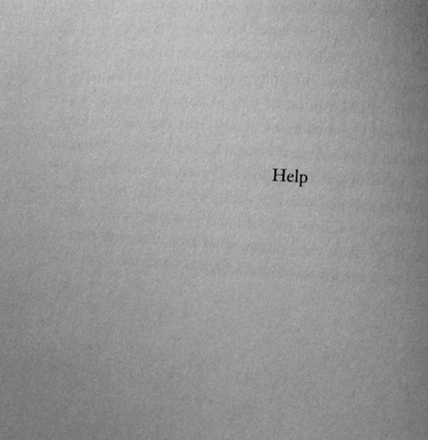
- How would you characterize the relationship between Oskar and his grandmother?

- Identify two symbols in the text. What does each represent?

- Do the graphic elements (illustrations, scribblings, over-written texts, etc.) in Extremely Loud and Incredibly Close add anything to the story? Detract anything? Are they distracting and gimmicky or do they serve to layer the text with new meaning? How? Explain why by citing at least 2 specific examples.

- Was this a sensitive portrayal of New York after the World Trade Center attacks? To what extent is fiction a constructive means of exploring September 11th and its aftermath?

See http://pasbenglishmsb.weebly.com/extra-credit.html for an optional extra credit assignment!

